DBMS LAB 3

V Venkataraman 106118106

Q1

use mysampldb;

DROP TABLE EMP;

CREATE TABLE EMP(

EMPNO INT NOT NULL,

EFNAME VARCHAR(100) NOT NULL,

ELNAME VARCHAR(100) NOT NULL,

JOB VARCHAR(100),

DEPTNO INT,

ECITY VARCHAR(100),

SAL FLOAT,

MANAGERNAME VARCHAR(100),

MANAGERNO INT,

PRIMARY KEY(EMPNO),

CHECK (SAL>0)

);

INSERT INTO EMP VALUES(1, 'Suresh', 'Raina', 'SDE', 1, 'Chennai', 100000.25, 'Jack', 101);

INSERT INTO EMP VALUES(2, 'Yuvraj', 'Singh', NULL, 2, 'Mumbai', 2000000.25,'MS' , 4);

INSERT INTO EMP VALUES(3, 'Virender', 'Sewhag', NULL, 3, 'Delhi', 300000.25, 'Jack', 101);

INSERT INTO EMP VALUES(4, 'MS', 'Dhoni', 'Sales', 1, 'Chennai', 40000000.25, NULL, NULL);

INSERT INTO EMP VALUES(5, 'Sachin', 'Tendulkar', 'Research', 2, 'Mumbai', 5000000.25, 'Mike', 103);

INSERT INTO EMP VALUES(6, 'Virat', 'Kohli', 'Research', 3, 'Bangalore', 400000.25, 'Chris', 104);

INSERT INTO EMP VALUES(7, 'Zaheer', 'Khan', 'Electrical', 1, 'Kolkata', 300000.25, 'Virat', 6);

INSERT INTO EMP VALUES(8, 'Ashish', 'Nehra', 'SDE', 2, 'Chennai', 300000.25, 'Chris', 105);

INSERT INTO EMP VALUES(9, 'Ravichander', 'Ashwin', 'Sales', 3, 'Chennai', 2000000.25, 'Jack', 101);

INSERT INTO EMP VALUES(10, 'Harbajan', 'Singh', NULL, 1, 'Delhi', 100000000.25, NULL, NULL);

select * from EMP;

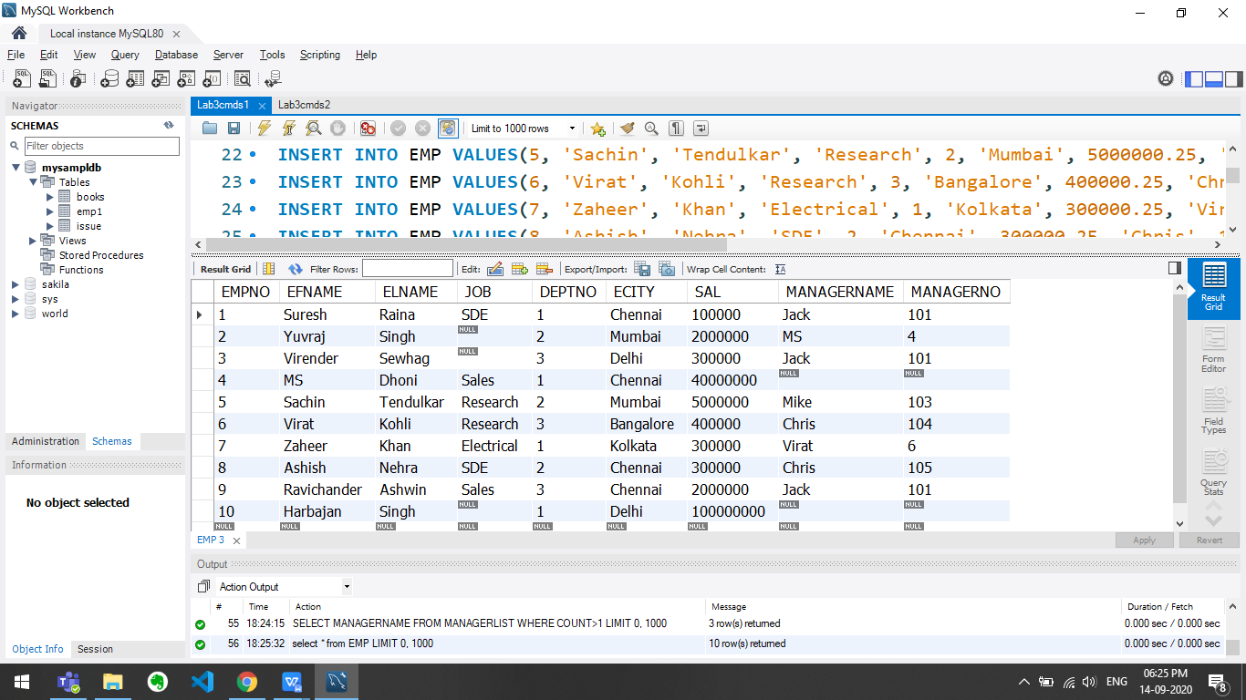

SELECT * FROM EMP ORDER BY

CASE

WHEN JOB IS NULL THEN DEPTNO

ELSE JOB

END

;

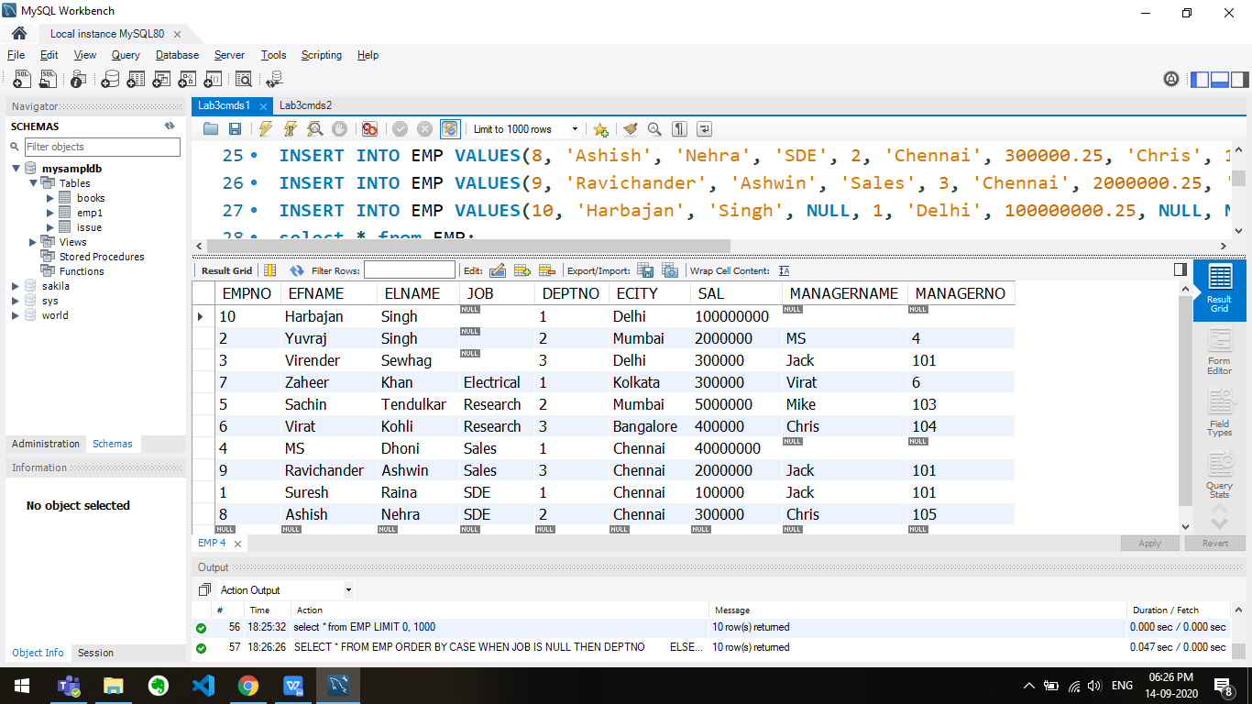

SELECT COUNT(*) FROM EMP;

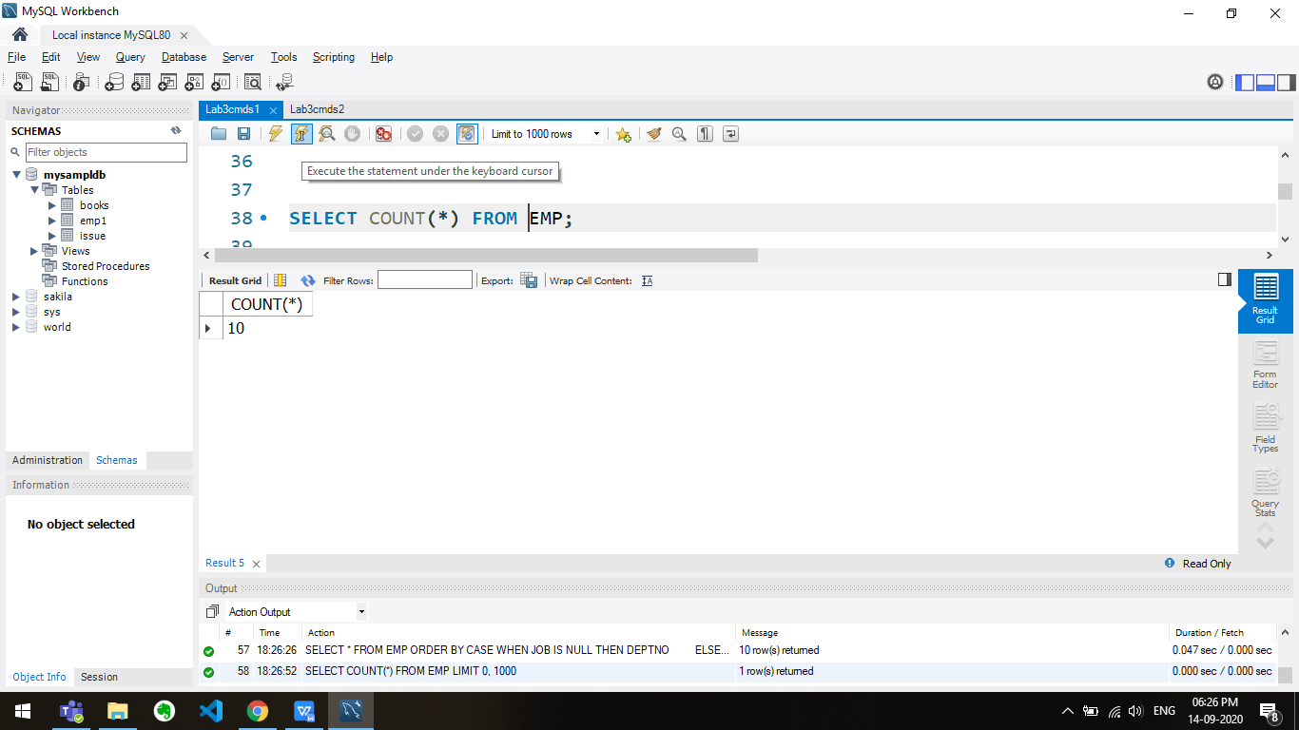

SELECT COUNT(DISTINCT JOB) FROM EMP;

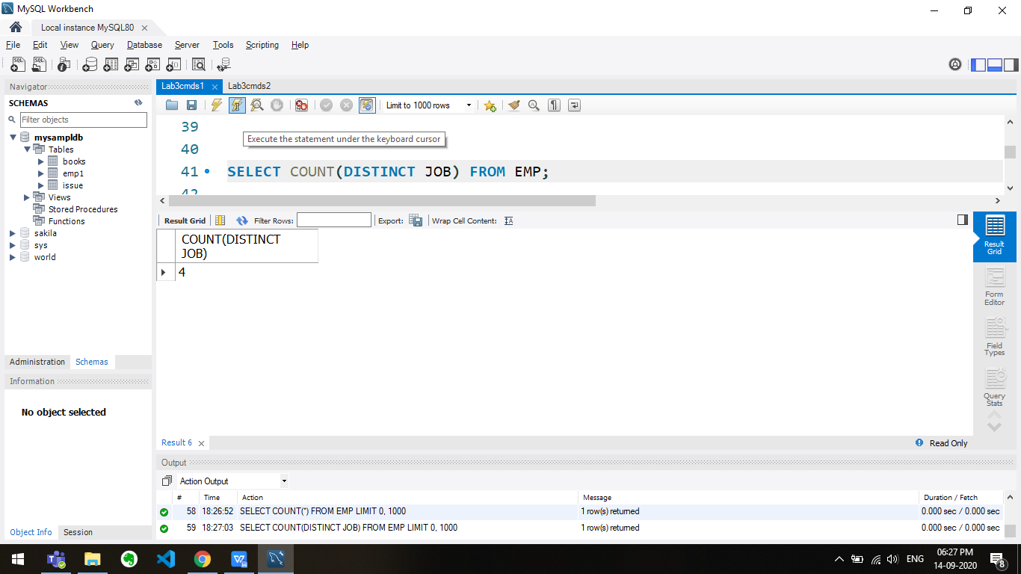

SELECT SUM(SAL), AVG(SAL) FROM EMP;

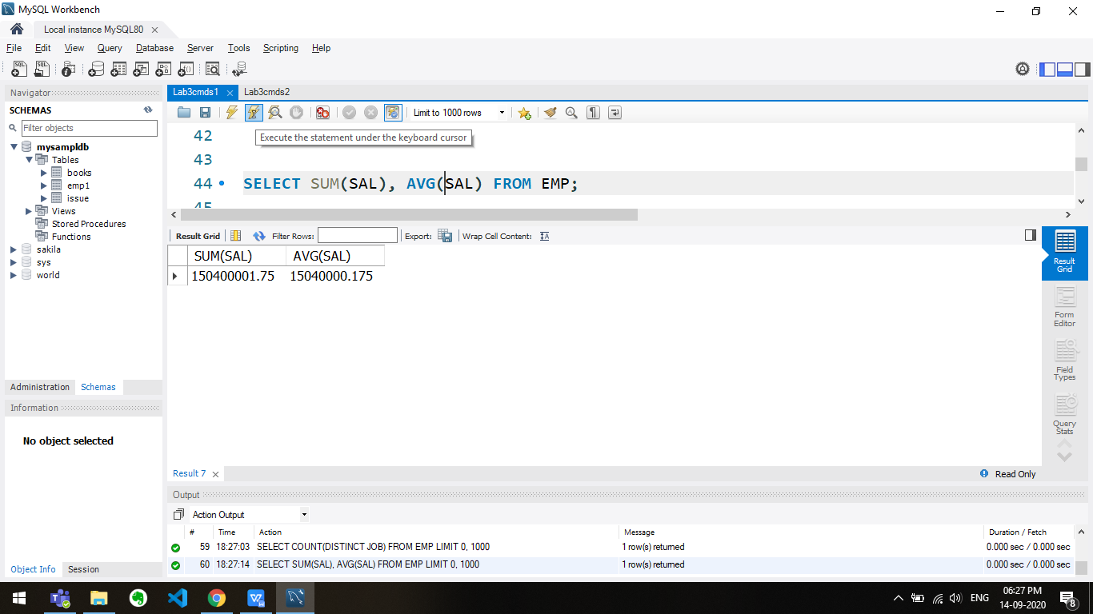

SELECT MAX(SAL) AS max_salary, MIN(SAL) AS min_salary FROM EMP;

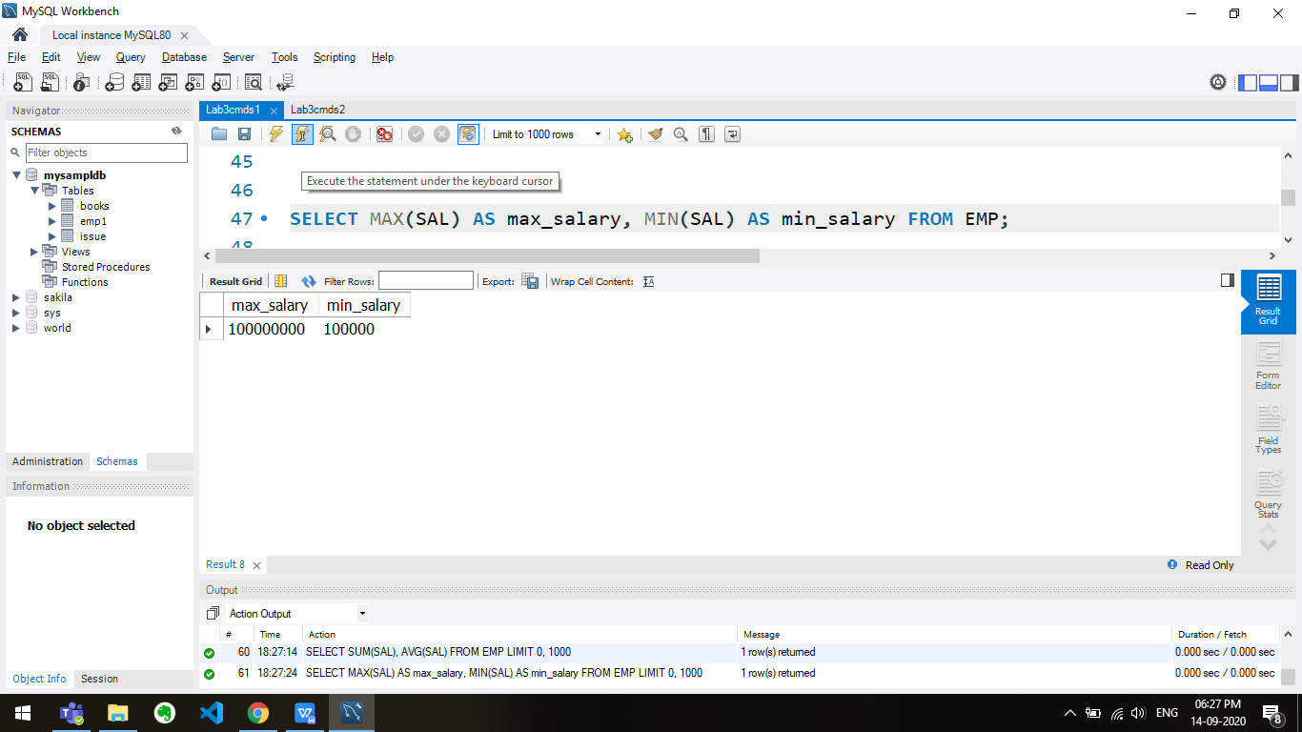

SELECT MAX(SAL) - MIN(SAL) AS difference FROM EMP;

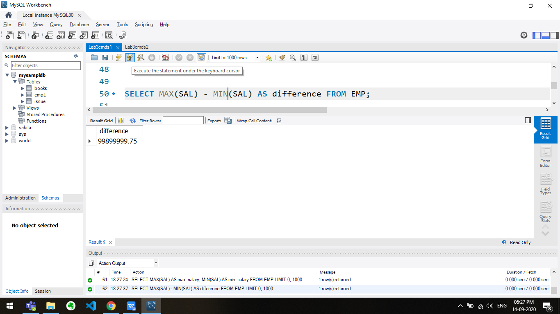

SELECT SUM(SAL), MIN(SAL), MAX(SAL), AVG(SAL) FROM EMP WHERE JOB = 'Research';

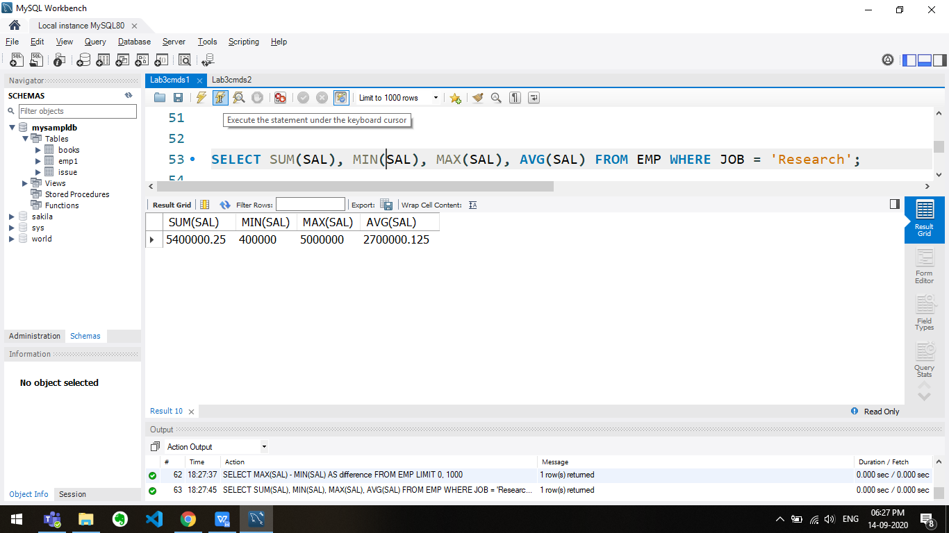

SELECT COUNT(DISTINCT SAL) FROM EMP;

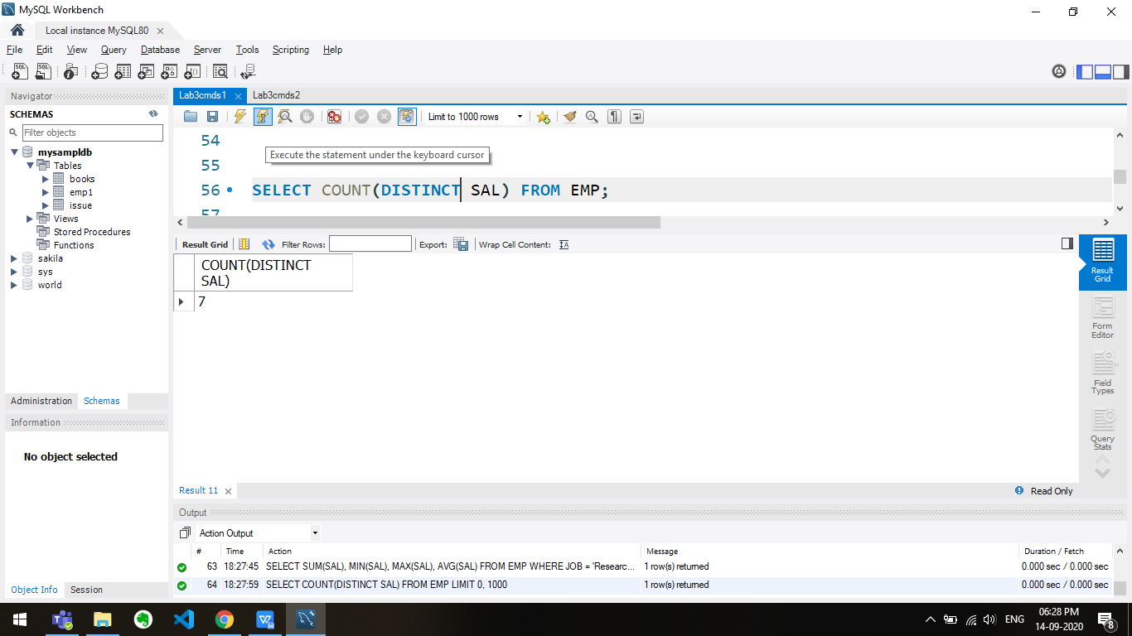

SELECT EFNAME, ELNAME FROM EMP WHERE MANAGERNAME IS NULL;

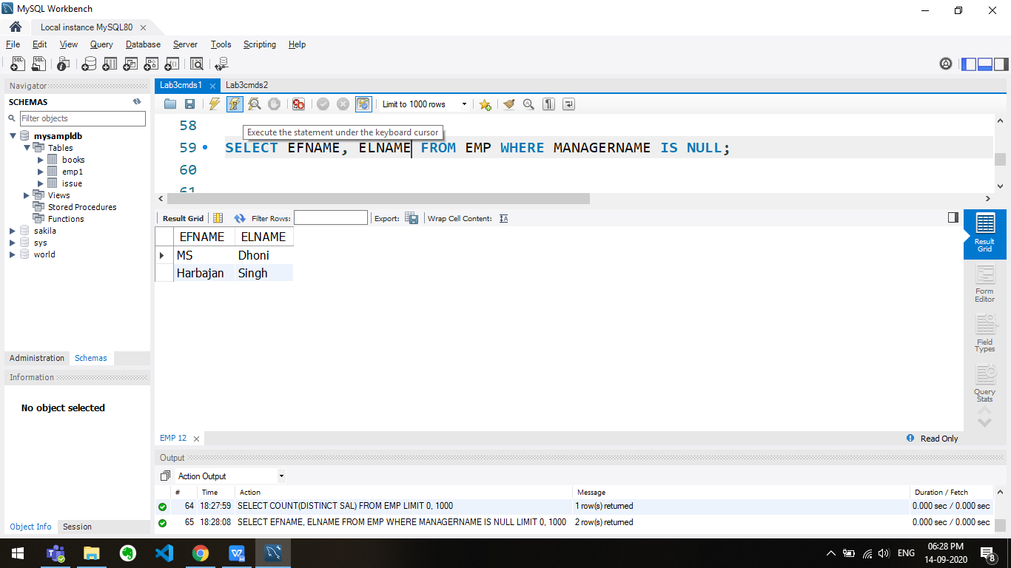

SELECT DEPTNO, COUNT(CASE WHEN SAL>700000 THEN 1 ELSE NULL END) FROM EMP HAVING DEPTNO IN

(SELECT DEPTNUMS FROM

(SELECT DEPTNO,COUNT(*) FROM EMP GROUP BY DEPTNO HAVING COUNT(*) > 5) AS DEPTCOUNT (DEPTNUMS, COUNT) );

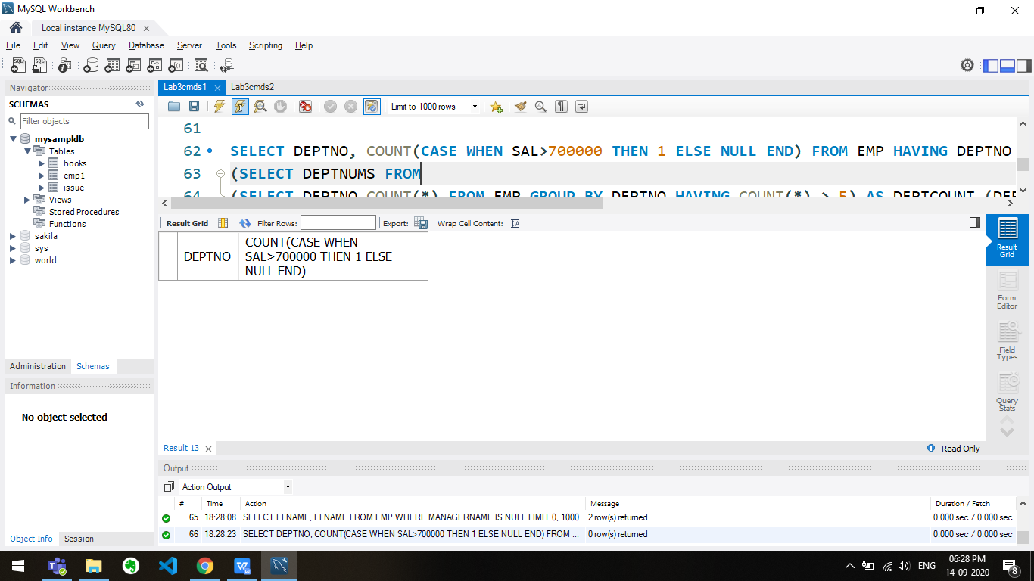

SELECT EFNAME FROM EMP WHERE EFNAME NOT IN

(

SELECT MANAGERNAME FROM EMP

);

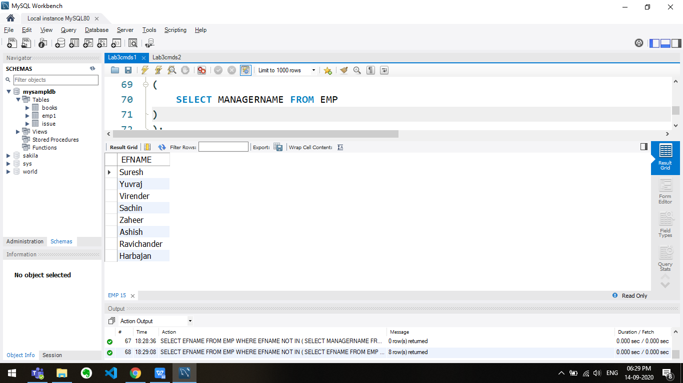

SELECT EFNAME FROM EMP WHERE EFNAME IN

(

SELECT MANAGERNAME FROM EMP

);

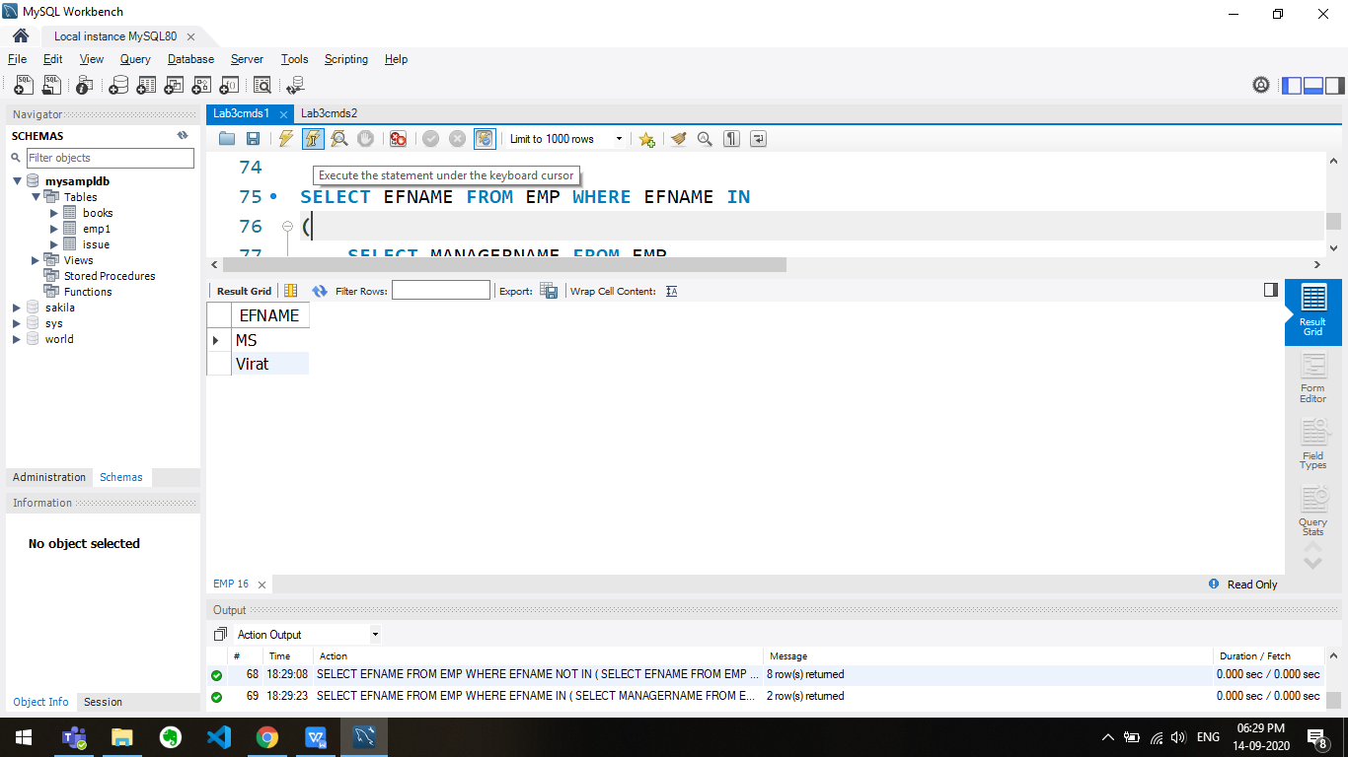

CREATE VIEW GOOD_CUSTOMERS AS

(SELECT EMPNO, MANAGERNAME FROM EMP WHERE EFNAME IS NOT NULL AND DEPTNO IS NOT NULL);

CREATE VIEW MANAGERLIST AS

(SELECT MANAGERNAME, COUNT(*) AS COUNT FROM GOOD_CUSTOMERS GROUP BY MANAGERNAME);

SELECT MANAGERNAME FROM MANAGERLIST WHERE COUNT>1;

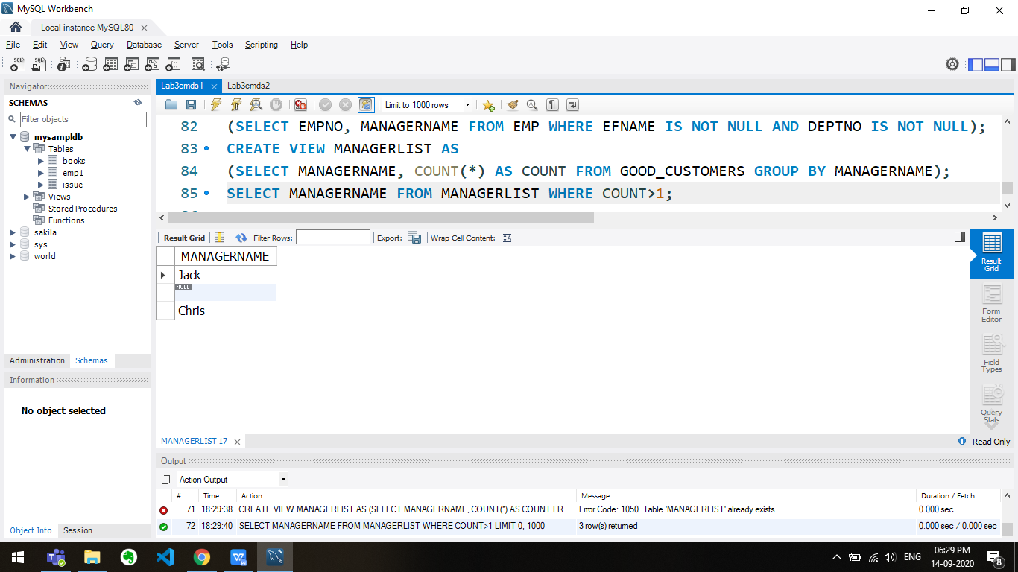

Q2

use mysampldb;

DROP TABLE Borrower;

DROP TABLE Depositor;

DROP TABLE Customer;

DROP TABLE Bank;

CREATE TABLE Borrower(

customer_name VARCHAR(100),

bank_no INT,

loan_no INT,

Amount FLOAT

);

CREATE TABLE Depositor(

customer_name VARCHAR(100),

bank_no INT,

account_no INT,

Amount FLOAT

);

CREATE TABLE Customer(

customer_name VARCHAR(100),

street VARCHAR(100),

customer_city VARCHAR(100),

PRIMARY KEY(customer_name)

);

CREATE TABLE Bank(

bankno INT,

Bankname VARCHAR(100),

city VARCHAR(100),

street VARCHAR(100),

PRIMARY KEY(bankno)

);

INSERT INTO Borrower VALUES('Rohan', 1, 1001, 2000000.50);

INSERT INTO Borrower VALUES('Sam', 1, 1002, 200000.50);

INSERT INTO Borrower VALUES('Akash', 2, 1003, 10000.50);

INSERT INTO Borrower VALUES('Krishna', 3, 1004, 2000.50);

INSERT INTO Borrower VALUES('Krishna', 3, 1005, 1000.50);

SELECT * FROM Borrower;

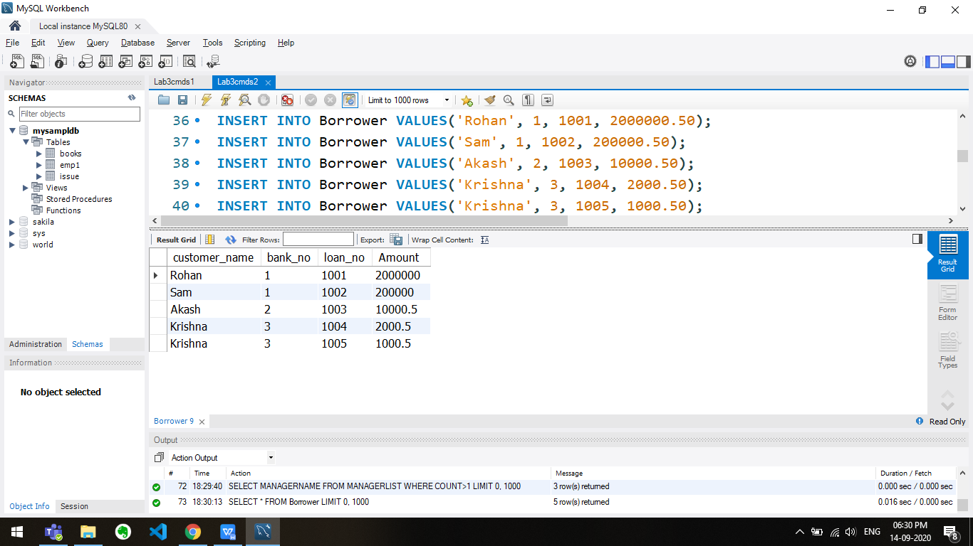

INSERT INTO Depositor VALUES('Rohan', 1, 1101, 20000.50);

INSERT INTO Depositor VALUES('Rohan', 1, 1102, 30000.50);

INSERT INTO Depositor VALUES('Sam', 1, 1103, 3000000.50);

INSERT INTO Depositor VALUES('Krishna', 3, 1104, 1000.50);

INSERT INTO Depositor VALUES('Jay', 4, 1105, 2000000.50);

SELECT * FROM Depositor;

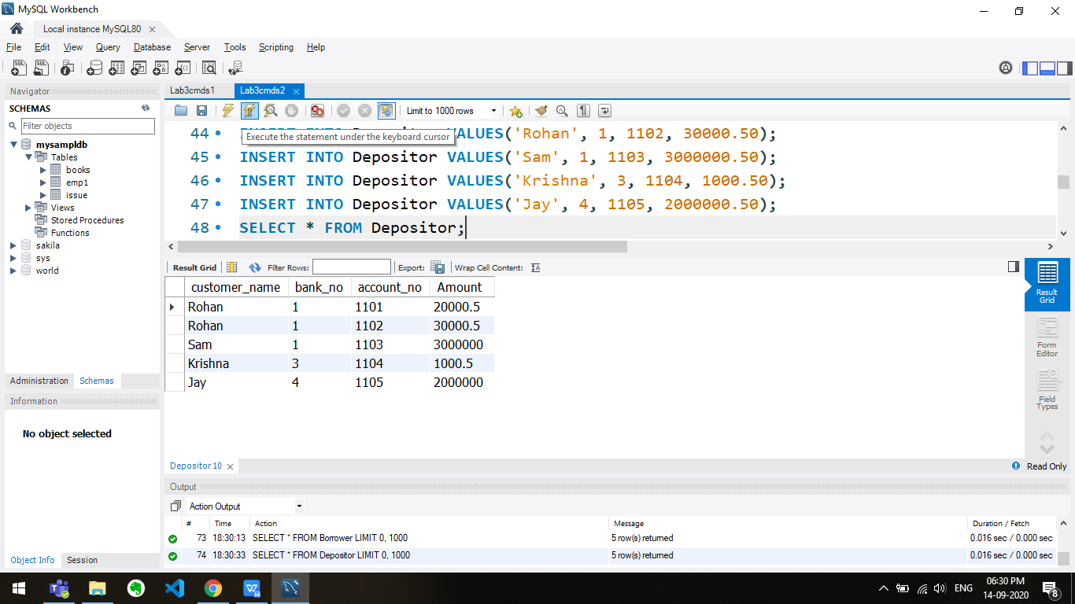

INSERT INTO Customer VALUES('Rohan', 'R street', 'Chennai');

INSERT INTO Customer VALUES('Sam', 'S street', 'Mumbai');

INSERT INTO Customer VALUES('Krishna', 'K street', 'Kolkata');

INSERT INTO Customer VALUES('Jay', 'J street', 'Kolkata');

INSERT INTO Customer VALUES('Akash', 'A street', 'Trichy');

SELECT * FROM Customer;

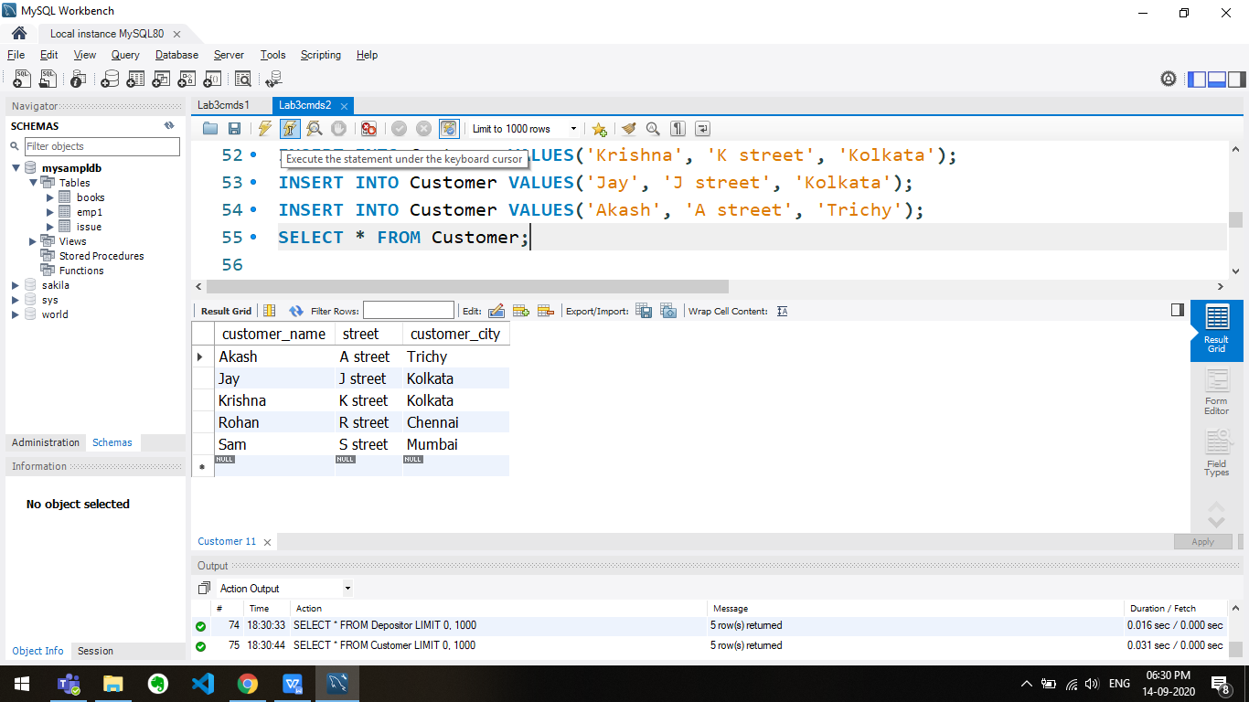

INSERT INTO Bank VALUES(1, 'HDFC', 'street 1', 'Chennai');

INSERT INTO Bank VALUES(2, 'JP', 'street 2', 'Chennai');

INSERT INTO Bank VALUES(3, 'Citi', 'street 3', 'Chennai');

INSERT INTO Bank VALUES(4, 'Axis', 'street 4', 'Chennai');

INSERT INTO Bank VALUES(5, 'SBI', 'street 5', 'Chennai');

SELECT * FROM Bank;

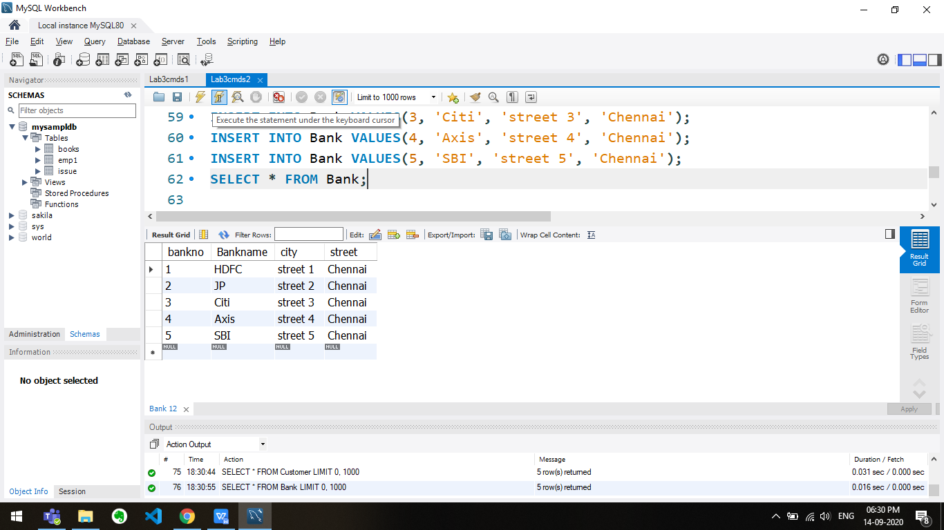

select customer_name from Borrower union

select customer_name from Depositor;

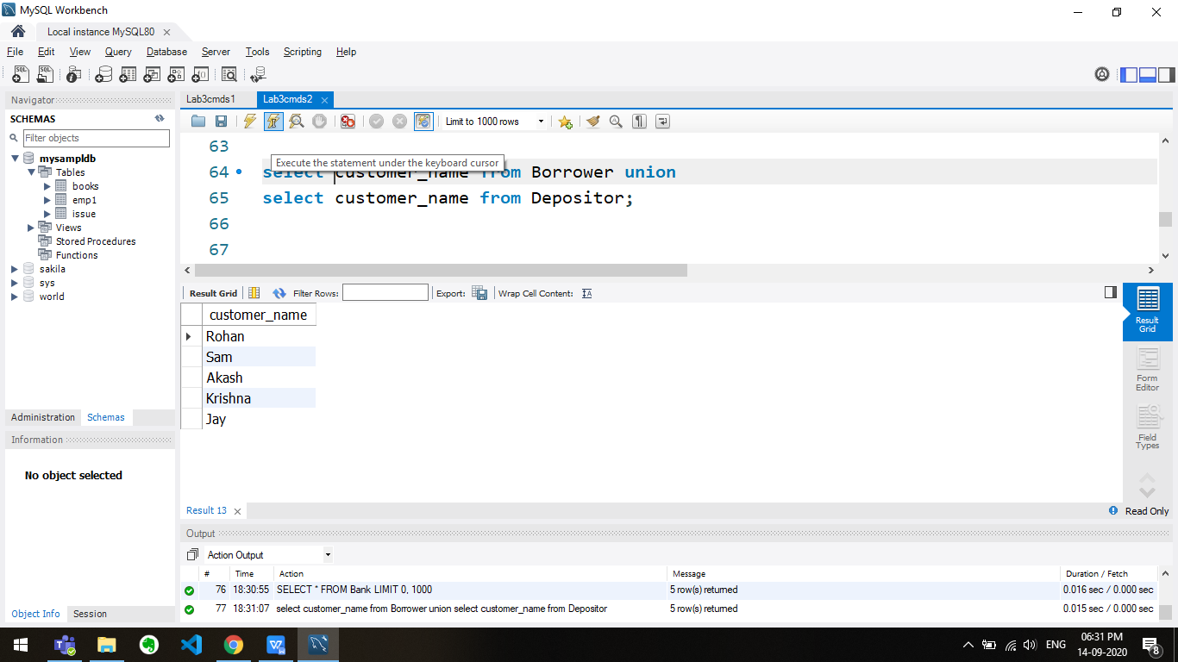

select customer_name from Borrower where customer_name NOT IN

(select customer_name from Depositor);

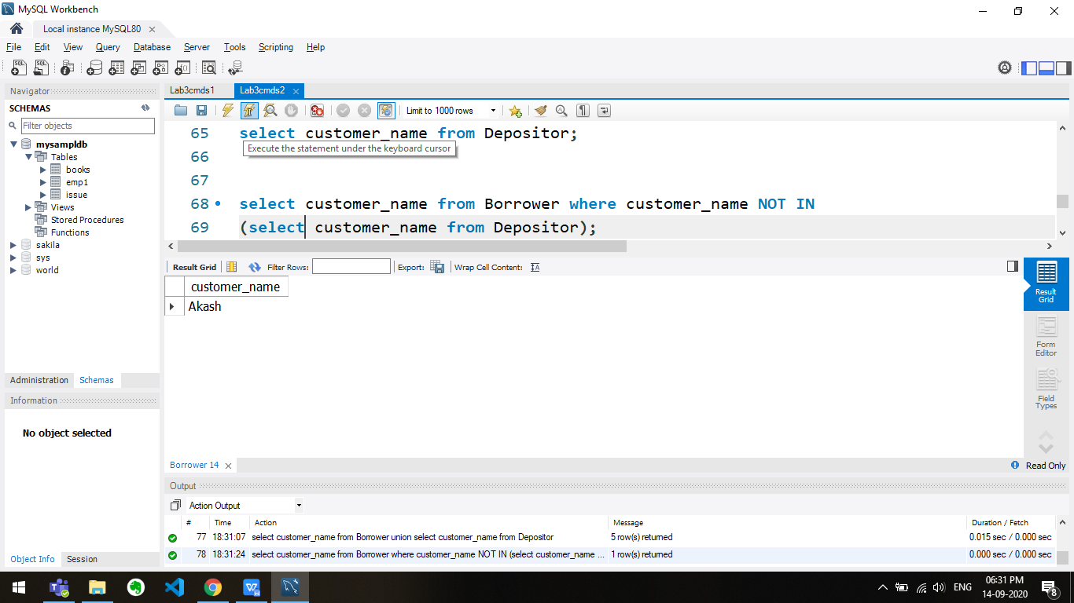

select Customer.customer_name from Borrower,Customer

where Borrower.customer_name = Customer.customer_name and customer_city='Trichy';

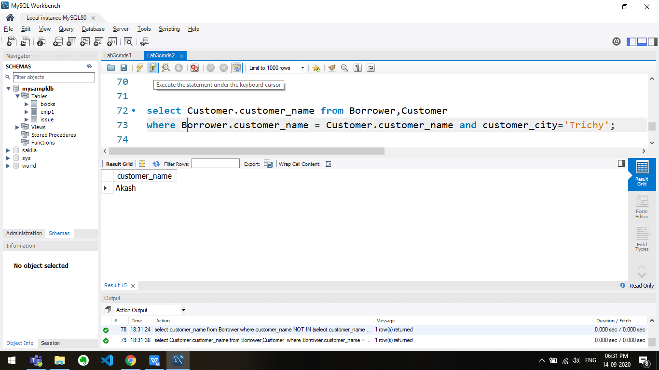

select Customer.customer_name, Customer.street, customer_city, bankno, Bankname, city, Bank.street

from Borrower, Customer, Bank

where Borrower.customer_name = Customer.customer_name and Borrower.bank_no = Bank.bankno

and Borrower.Amount >1000000;

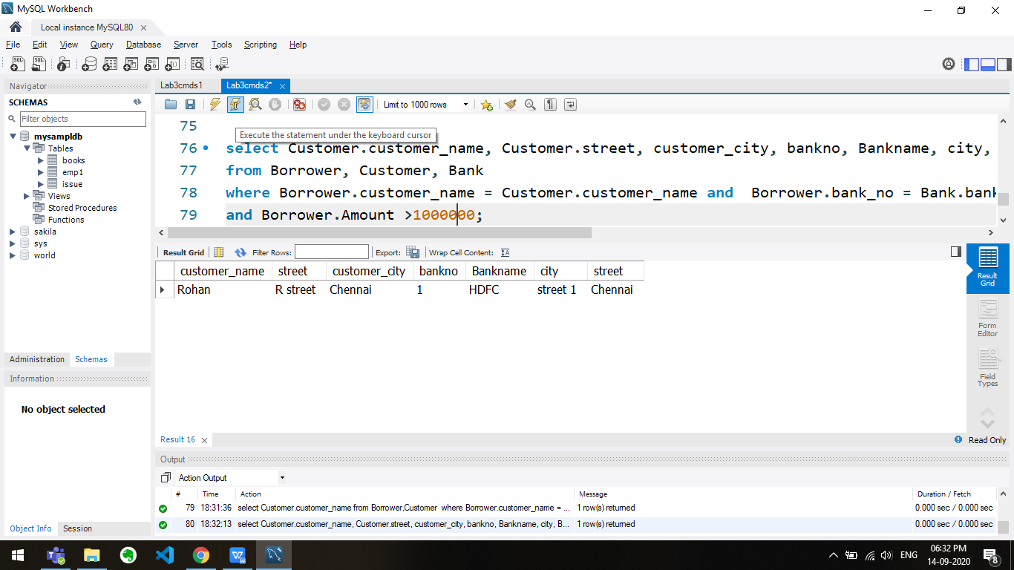

select Distinct Customer.customer_name from Customer,Depositor,Bank where Customer.customer_name = Depositor.customer_name

and Depositor.bank_no = Bank.bankno and customer_city=city;

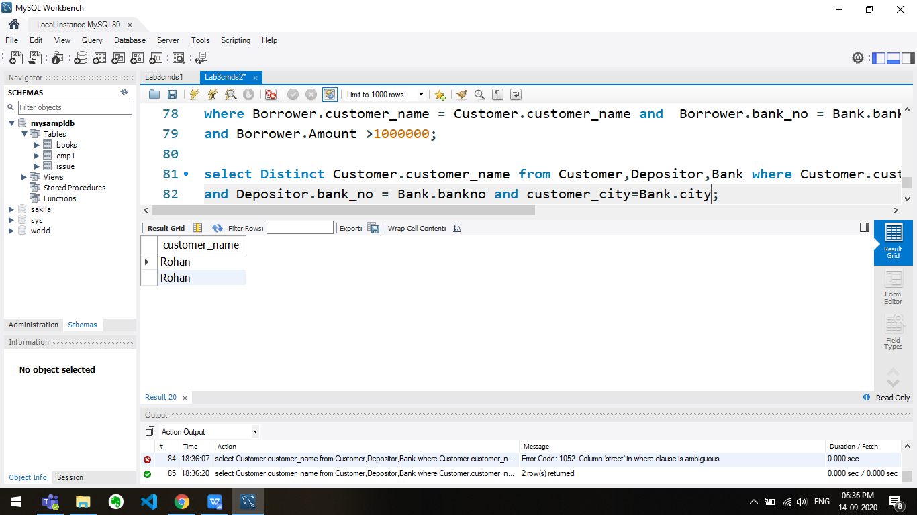

select bank_no from Borrower where Amount in (select max(Amount) from Borrower);

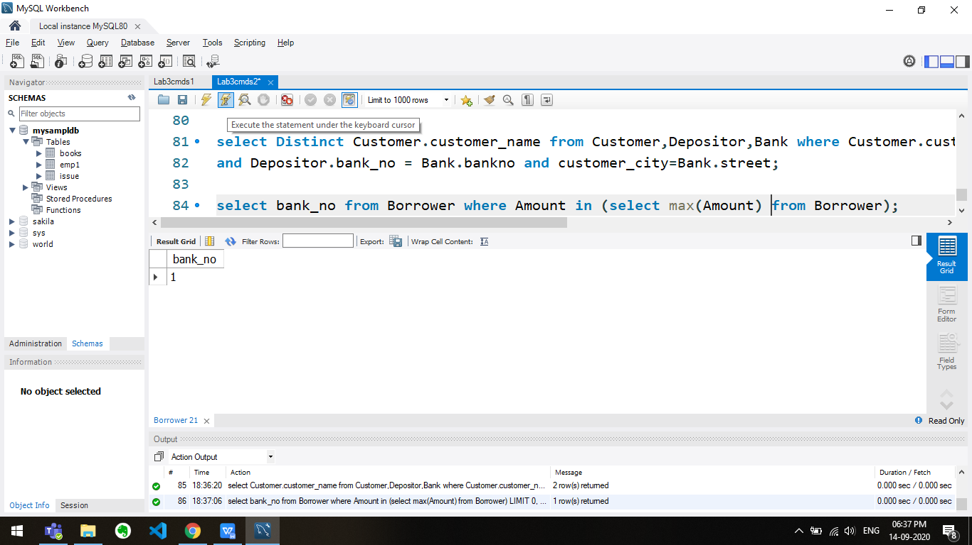

DELETE Customer, Depositor, Borrower FROM Customer, Depositor, Borrower

WHERE Customer.customer_name = Borrower.customer_name OR Customer.customer_name = Depositor.customer_name;

SELECT * FROM CUSTOMER;

